**We ask that you read & adhere to all our Covid-19 requirements to ensure we are all keeping safe.**

**We have reduced capacity by 50% to ensure we are compliant with social distancing rules whilst you are in the salon.**

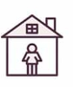

**STAY AT HOME**

**If you feel at all unwell or have any symptoms of COVID-19 please cancel your appointment as a priority and we can reschedule it for you. Please note that no other guests can accompany you to your appointment.**

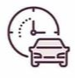

**APPOINTMENT DAY**

**Please arrive at the right time for your appointment and we ask that you do not come in early or late as our treatment timings are strictly scheduled. Please also note all clients details will be kept in our system for track & trace compliance as per government requirements.**

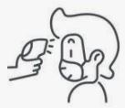

**TEMPERATURE CHECKS**

**We will be taking all our teams temperature when they start work and will also be taking client temperatures before they enter the salon. A temperature reading above 37.5c would determine an appointment cancellation.**

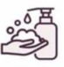

**HAND HYGIENE**

**Please sanitise your hands on arrival with the hand sanitiser gel provided. Our team will be frequently washing their hands before, during & after every client as well as using a new pair of gloves.**

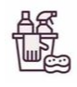

**SALON HYGIENE**

**We will be using surgical spirit on all surfaces, including door handles every 60 mins. We will also allow time in between clients to clean and sanitise all areas prior to the next clients arrival.**

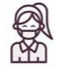

**FACE MASKS**

**We require all clients to wear a face mask throughout their visit to the salon. Our team will also be wearing a face mask at all times and mask with a shield when undertaking face treatments.**

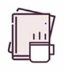**DRINKS & MAGAZINES**

**We will not be serving drinks during appointments for the foreseeable future but will have disposable cups for water.**

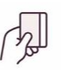

**PAYMENTS**

**Contactless and card payments will be the required method of payment to ensure that we keep cash handling to minimum.**